Dec 4, 2021 Intergroup meeting minutes
Attendees: Valarie L, Chair; Nikki L, Co-chair, Emily L, Co-chair elect; Margaret C, Secretary; Steve W, Intergroup-District liaison, Treasurer elect; Ann T, Webmaster, Carly N – Communications, Secretary elect; Jen L, Treasurer; Teresa R- visitor, Rick – visitor; Bret S – Midwest group; Kelsey N- Young people
Chair Reports:
Secretary (Margret C) – minutes from November mtg read and approved.

Treasure Jen L. Steve W and Jen will meet next week to transfer treasurer info. Steve added to Hills Bank account. Jen will unlink her personal PayPal and Venmo accounts from the intergroup account. Monthly bills are generally Answer Iowa and Verison.

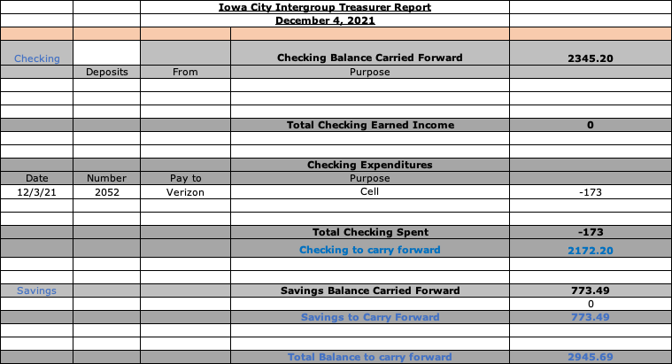

Phone Chair Sarah S. Not able to attend

Intergroup District Liaison- Steve W. District is working on a website, which is still under construction. 270 members attended the Fall conference. Current treasurer balance is $969.70 (10/23/2021). Steve will ask district to post District position emails on website. Some confusion on meeting schedules – to be addressed in new business.

Communications- Carly N – NYE survey results to date : about 70% of 52 respondents prefer in person event. Still need someone to take over this position. Valarie will check with young people to see if a social media/tec savvy member is interested.

Webmaster – Ann T Annual fee for Zoom account is coming up ($150). Cost for larger capacity Zoom meeting is $50 for a month. Ann was able to unhook the plug in schedule for daily meetings which was not up to date. She is posting the District meeting schedule of in person meetings on the website. Made change to Monday Tiffin mtg to reflect it is Open, not Closed per Rick W.

Group Reports
Margaret C – Thursday By the Book 6:30pm. Meetings still on Zoom only. Good attendance. No movement yet to go in person.
Rick W – Tiffin Monday night. Meets at &pm. In person. Attendance is 6-15 members. Rick will cover this position until new rep is elected.
Bret S – Midwest group . Unable to report on what is going on with the group as he is unable to attend.
Emily L – Sunday LCBTQ group. Zoom only. Meeting is steady. Attendance is 15-20 weekly. Still looking for Intergroup Rep. Will serve as Intergroup rep for this group if group approves.
Kelsey N – Young People. Meeting in person. Saturday at 8pm. Involvement in service positions is low, hence the Young People will not be able to cohost NYE event, but will support.

Old Business: NYE party. After much discussion, the group voted to move the event to a totally virtual event related to increases and unknowns in COVID situation. Ann will secure the larger capacity Zoom meeting for that night. Nikki was able to secure Lou as DJ for the night. All speakers ok to attend virtually. All costs associated with the virtual event were unanimously approved. Intergroup will meet again Saturday December 11 at 10am to complete planning.

Intergroup By-laws: Discuss on Saturday Dec 11.
Schedule issues: discuss Saturday Dec 11.
Zoom account – approved to renew for another year.

New Business – no new business.

Next meeting will be Saturday December 11, 2021 at 10am on Zoom to complete planning for NEW event. Need to determine date for January meeting as 1st Saturday of the month will be January 1. Log in: 853 291 5303, Password: Wilson

In service, Margaret C, Secretary

