Nov 6 2021 Intergroup meeting minutes
Attendees: Nikki L, Co-chair, Emily L, Co-chair elect; Sarah S Phone chair: Margaret C, Secretary; Steve W, Intergroup-District liaison, Treasurer elect; Ann T, Webmaster, Carly N – Communications, Secretary elect; Teresa R- visitor, Rick – visitor; Bret S – Midwest group; Kelsey N- Young people
Chair Reports:
Secretary (Margret C) – minutes from October mtg read and approved.

Treasure Jen L. October report sent late. Will be approved next meeting.
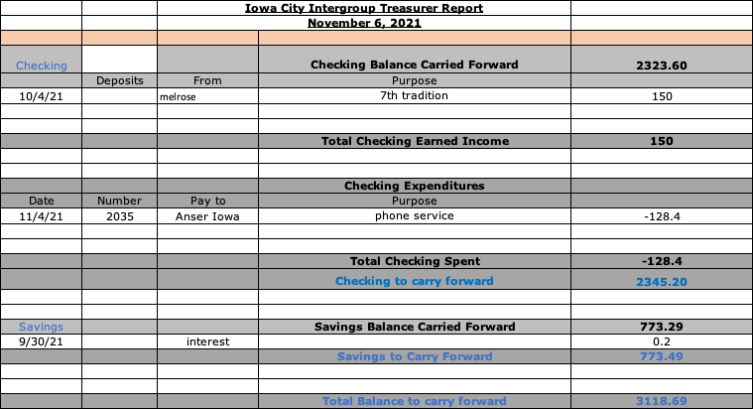

Phone Chair Sarah S. Phones are being answered.

Intergroup District Liaison- Steve W. Nothing to report

Communications- Carly N – NYE survey results to date : 18 will attend inperson, 13 will attend virtual, 8 will not attend. Suggested Intergroup members post survey link directly in chat at all zoom meetings they attend :
https://www.surveymonkey.com/r/NT99JVK

Webmaster – Ann T Working to keep schedules updated. Will try to disable calendar of meetings on left side of page since it is not accurate. Will post a pdf of District paper monthly inperson schedule on website.

Group Reports
Margaret C – Thursday By the Book 6:30pm. Meetings still on Zoom only. Good attendance. Saturday pop-up speaker meeting going well with good attendance. Will continue as long as weather permits.
Bret S – Midwest group .Has not been able to attend this group for a while because of work conflict. Speakers weekly. Reported on groups participation in young peoples conference last August. Per Teresa R – attendance is 20-25 weekly. Meeting is one hour only – no break at this time.
Ronnie W – Melrose groups. Melrose is doing well. Masks being worn.
Emily L – Sunday LCBTQ group. Zoom only. Attendance is 20-25 weekly. Will serve as Intergroup rep for this group if group approves.
Kelsey N – Young People. Meeting in person. Attendance is decent, all wearing masks. Some chair positions filed last week.

Old Business: NYE party. We still need more survey responses to plan well, but it appears we will be doing a hybrid model. Members who invited panel speakers will check to see if speakers will attend inperson or by zoom. ((Erin B, Jason H, Jenny B, Ryan M). Motion to ask if Young People would like to cohost as they will likely have more inperson attendees. Approved. Kelsey will ask the group if this is something they would like to do at the meeting tonight. Will also ask St Andrews if they will allow us to use the space and check what accommodations they have for hybrid meeting. Ronnie will check with Melrose groups again to see if more might be interested in attending. Interest has been low so far. Kelsey will try to get a head count of young people planning to attend at tonight’s meeting. Looking at a time frame of 6;30 – 11PM. Panel of speakers at 7:30
Further planning to address next month:
- Do we need expanded Zoom capacity for the event
- Food, drinks, entertainment
- Child care need
- Flyer
- Meeting details – readers, etc.

Intergroup By-laws: Nikki will communicate with Valarie re getting amended by-laws to group members for approval and get updated by laws on website (minus tax ID info).

New Business – no new business.

Next meeting will be Saturday December 4, 2021 at 10am on Zoom. Log in: 853 291 5303, Password: Wilson

In service, Margaret C, Secretary

