Aug 7, 2021 Intergroup meeting minutes
Attendees: Valarie L., Chair; Nikki L, Co-chair; Sarah S Phone chair: Margaret C, Secretary; Ann T, Webmaster; Jamie F, – Young People; Bret S, Midwest group. Jen L, Treasurer; Steve W, Intergroup-District liaison; Steve W, Intergroup District Liaison
Chair Reports:
Secretary (Margret C) – minutes from June mtg read and approved.

Treasure Jen L.
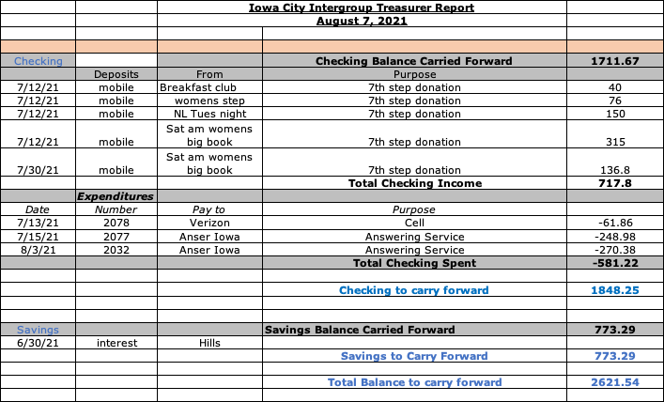

Phone Chair Sarah S. Phones are being answered.
Intergroup District Liaison- Steve W

Webmaster - Ann T. Nothing new to report. Has some new business to discuss.

Communications- Carly N – Unable to attend. Nothing new to report.

Intergroup District Liaison – Steve W – July district meeting – working on a website. Supplying Prelude with AA literature.

Group Reports
Bret S – Sunday Midwest – All in person. No Zoom. Went live in July. Attendance is 15-25.

Margaret C – Thursday By the Book 6:30pm. No change. Meetings still on Zoom. Working on setting up a hybrid meeting for the near future. Some members from this group have started a temporary in-person outdoor open speaker meeting Saturdays at 5:30 at the N. Market Sq. Park. Attendance has been good. All are welcome.

Jen L -Blue Noon:
Beginning August 2, 2021, Blue Noon will meet every Monday and Friday from 12:10 PM to 1:00 PM in Gathering Room 6 on the lower level of Zion Lutheran Church at 310 N. Johnson Street in Iowa City, Iowa.
We are set up for a "hybrid" meeting, meaning that those who cannot attend in person will still be able to zoom in (421 94 515) and those at the meeting in person will pass a mike when it is our time to share. We agreed to pay Zion $75.00 per month for the privilege of using this room, which means that we will need to average about $10.00 per meeting in contributions just to pay the rent. Zion has an adequate parking lot adjacent to the church which we are welcome to use. We may enter the building through the front door or the door on the east side, then proceed to the basement level to find Gathering Room 6. The door on the east side has a handicap accessible elevator to the lower level.

Jamie F – Young People Young People’s Meeting update:
Young People’s group is still meeting in-person at St. Andrew Church on Saturday’s at 8pm. Attendance ranges from 15-35 people per meeting.

Ashley T- Intergroup liaison for Young Peoples conference – IAYPAA 5 Conference:
IAYPAA 5 Conference (August 20th - 22nd)
Saturday, August 7th (Conference Kickoff Event) - Pie in the Face Potluck (flyer attached), from 12pm-5pm. Main dish provided (burgers, hot dogs) but being a side to share. William Creek Park.
Conference is currently scheduled to be in-person. There will be a discussion on this at our next Host Committee Meeting on Sunday, August 8th.

Old Business
Intergroup By-laws: Valarie will resend amended by-laws and we can revies next month.
Spring Banquet- Currently scheduled for October 2. City park shelters are available. Will we hold the event? Decision to plan the event and cancel if COVID numbers are high. Ann will reserve the shelter. Panel of speakers is set: Erin B, Jason H, Jenny B (Ryan had to cancel). We will confirm next month whether or not to move forward.

Intergroup Elections: These will be held in October. Ann will make a flyer to post on the Intergroup website. Nikki, Steve W, Ann T , Sarah S will stay on. Nikki will move to Chair position. Steve is willing to do another position. Current chairs and intergroup reps will spread the word at meetings re election and need for new chairs – treasurer, Co-chair, secretary, Intergroup District Liaison,

New Business
Ann T – webmaster – is looking to hire a consultant for help with the website. Has an IT person in mind. Group voted to authorize up to 4 hours at $50/hour for a consultant.

Next monthly meeting will be Saturday September 11, 2021 on Zoom. (Rescheduled related to Labor Day holiday.
Zoom ID: 853 291 5303
Password: Wilson

In service, Margaret C, Secretary

