July 3, 2021 Intergroup meeting minutes
Attendees: Nikki L, Co-chair; Sarah S Phone chair: Margaret C, Secretary; Ann T, Webmaster; Ronnie W, Melrose Rep; Barb M, Saturday Women’s, Carly N, Communications chair
Unable to attend- sent reports: Ashly T, IAYPAA5 liaison; Meg Q – Young People; Teresa R, Midwest group. Jen L, Treasurer Steve W, Intergroup-District liaison
Chair Reports:
Secretary (Margret C) – minutes from June mtg read and approved.

Treasure Jen L.
Treasure’s report not available until after the meeting. Can be read and approved next meeting.
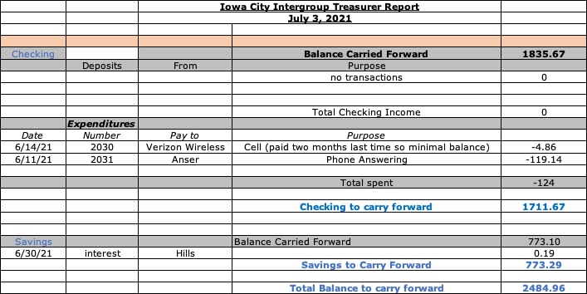

Phone Chair Sarah S. Nothing new to report
Intergroup District Liaison- Unable to attend.

Webmaster - Ann T. Still asking for suggestions for a description of Intergroup to use on the website. Archive materials passed on to Steve W for sorting.

Communications- Carly N – nothing new to report.

Intergroup District Liaison – Steve W – sent flyers for Melrose Garage Sale and IAYPAA upcoming conference, August 20-22. Flyers available on Intergroup website.

Group Reports
Teresa R – Sunday Midwest – We are back to meeting in person Sundays at Zion Lutheran Church, 310 N Johnson Street, Iowa City, IA, same format, first half topic/share and then a 30-minute speaker. It has really been nice to be together again, and the church has been lifting covid guidelines so will keep you updated as they roll out. Our next monthly business meeting will be on July 11th, the second Sunday of the month at 5:30 pm, and will still be on Zoom this month, will be back at the church in August, zoom # 980 0985 6811—there is NOT a password. It you are looking for a way to be of service and a great home group come join us.

Margaret C – Thursday By the Book 6:30pm. No change. Meetings still on Zoom. We will meet with Trinity to discuss room options. Day and time are still available to us (Thursday at 6:30pm. Some members from this group have started a temporary in-person outdoor open speaker meeting Saturdays at 5:30 at the N. Market Sq. Park. Attendance has been good. All are welcome.

Ronnie W – Melrose: Not a lot going on. Biggest discussion is whether or not to bring back coffee. Melrose needs a new coffee pot – old one is beyond cleaning. Meetings going well – attendance is picking up. Breakfast Club asked Ronnie to cover as Intergroup rep for this meeting as well. Meeting daily in person. Meetings going well.

Barb M. Saturday Women's Big Book study-
The group is still meeting on Zoom. We will have our regular business meeting on July 10.
At this meeting, we will also discuss how to move forward towards going back in person. The discussion will focus on 4 possible options:
1) Remain on Zoom
2) Go totally in-person(Gloria Dei has give the OK for us to return to the church.)
3) Hybrid- in-person meeting with Zoom option
4) Two separate meetings: one in-person and one on Zoom.

Meg Q – Young People Young People’s Meeting update:
Nothing to report on behalf of Young People's Meeting aside from we are still meeting on Saturdays at 8pm at St. Andrew Church. Attendance has been steady at 20-30 people.

Ashley T- Intergroup liaison for Young Peoples conference – IAYPAA 5 Conference:
- We are having a Garage Sale next Saturday, July 10th from 9am-3pm in the parking lot of Melrose. If you have items you wish to donate you can contact Corey F (his number is on the flyer which is attached).
- you can still register online for the conference at www.IAYPAA.com
- you can also donate via Venmo or PayPal. Both handles are @IAYPAA5
As soon as I hear back from you all on the full details of the event I will get a flyer done for you all to review!

Old Business
Intergroup By-laws: Table until next meeting.
Archives – Ann passed archive materials on to Steve to review.
Spring Banquet- Quotes for sandwiches (thanks, Meg) were high - $5.50-$6 for individually wrapped. Ronnie will check with Pita Pit for quote for 50-75 individually wrapped.
Since so few members were able to attend, a group decision was made to postpone event so it can be well planned. October 2 is first upcoming Saturday after August with no home football game (other then IA, IA State) so decision to hold event on October 2, 2021 was agreed upon. Ann will check to see if park is still available for that date. We will notify speakers (Erin B, Jason H, Jenny B, Ryan M) of date change.

New Business
Intergroup elections – table to next month

Next monthly meeting will be Saturday August 7, 2021 on Zoom.
Zoom ID: 853 291 5303
Password: Wilson

In service, Margaret C, Secretary

